Networking Your Students' Neurons
Click to Print
Submitted by King on Wed, 2012-05-09 14:31
The Internet began as a U.S. military computer network meant to survive a nuclear attack. ARPANET, developed in the 1960's, stored information in a broad network of computers linked by distributed hubs so that an attack against one or more hubs could not bring down the entire thing.
Decentralized. Interconnected. Robust. Nuke-Proof.
Wouldn't it be great if you could get your students to build the same kind of neural networks around the subjects you teach? How can you move beyond superficial, short-term learning to create learning that sticks? Modern brain science suggests one answer that you can apply in your classroom today.

Providing a Sensory Banquet
The key to creating robust neural networks in students' brains is to give them a rich sensory diet as they engage with material. Here's what Ronald Kotulak says in Inside the Brain:
The brain gobbles up its external environment in bites and chunks through its sensory system: vision, hearing, smell, touch, and taste. Then the digested world is reassembled in the form of trillions of connections between brain cells that are constantly growing or dying, or becoming stronger or weaker, depending upon the richness of the banquet.
By engaging many different senses, you lay the information down through multiple interconnected neural pathways, placing it in long-term memory and making it robust and "nuke-proof."
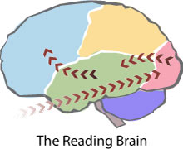
Map of the Reading Brain: Imagine that you ask your students to read a paragraph about the Treaty of Versailles. The information comes in through the eyes, imprints upon the retinas, and then travels through the optic nerves to the occipital lobe at the back of the brain. The information there is decoded into words, and impulses travel to the temporal lobes, where language processing occurs. The impulses then arc up to the frontal lobe meaning of the words is evaluated.
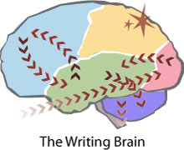
Map of the Writing Brain: If you now ask students to freewrite to reflect on the Treaty of Versailles, the brain fires back and forth between the frontal lobe and the temporal lobe, putting thoughts into words. It also sends signals back and forth between the frontal lobe and the limbic system as students explore their feelings about the treaty. Meanwhile, neural pathways fire from the temporal lobe to the cerebellum, which controls the motor neurons that make the fingers move the pen or press keys on the keyboard. And, of course, when a student writes, he or she is also simultaneously reading, so the map of the reading brain gets overlaid on that of the writing brain. The parietal lobe monitors it all, helping with sensory integration.
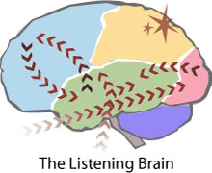
Map of the Listening Brain: After students write paragraph reflections on the Treaty of Versailles, you ask them to share their thoughts with the class. One student speaks, and the others listen. The impulse this time comes in through the ears and gets processed in the temporal lobes and also the limbic system. Much of the meaning of oral communication comes through tone of voice, which reveals the speaker's feelings about the topic, the audience, the context, and the purpose. And don't forget about the eyes. Much more information comes from nonverbal cues such as posture, facial expression, and gesture. So the signal from the eyes goes to the occipital lobes and through the limbic system before converging with the auditory signals in the frontal cortex. Again, the parietal lobes help integrate the senses.
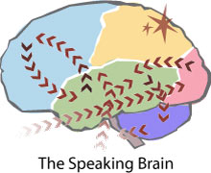
Map of the Speaking Brain: When the time comes for a given student to read thoughts aloud, we have the reading brain map overlaid on a speaking brain map, which works much like the writing brain did. This time, however, the motor impulses go to the mouth instead of the fingers. And, of course, as we speak, we listen to ourselves and others around us, so the listening map is also overlaid. And the parietal lobe is once again integrating all of the impulses.

From Communicating to Collaborating
So, we've seen how multimodal presentation styles—visual, auditory, oral, and motor—fire the brain in different ways, creating diverse connections and pathways about a specific topic. But students can also go beyond reading, writing, listening, and speaking—by collaborating together for a common goal.
Imagine that you assign students to be ambassadors from the Allied Powers who constructed the Treaty of Versailles. Each student will represent one of the Allied nations—France, Britain, Italy, the United States, or Japan. Groups of five students must convene to create a new Treaty of Versailles to try to fix the problems with the actual treaty. Students must think about what their nations need, what other nations need, the problems with the original treaty, ways to address the problems—and all while acting, reacting, and interacting. Every sensory system and every motor system is engaged, and the emotional context is critical as well. Students are experiencing the Treaty of Versailles, not just reading about it and taking a test. This rich banquet of sensory and motor experience means the information will be well and truly learned, placed in long-term memory.
In his article, “Neural Pathway Development,” Dr. Gene Van Tassell shows how learning through varied sensory pathways can help shift information from short-term memory (STM) to long-term memory (LTM):
Memories can be stored with visual, audio, or other sensory perceptions. These types of storage are part of an LTM system. Educators are wise to encourage LTM storage as opposed to STM storage, which requires rehearsal and a minimum of cross referencing in the labeling system. With more pathways sensitized and networked within the brain, it is easier to access items in the memory where they might be stored.

