Deep Learning through Concept-based Inquiry

by Jean Donham
Jean Donham, Ph. D., teaches in School Library Studies at the University of Northern Iowa. She is author of Enhancing Teaching and Learning, A Leadership Guide for School Library Media Specialists (Neal Schuman, 2008).
con·cept (kŏn’sěpt’) n.
1. A general idea derived or inferred from specific instances or occurrences.
2. Something formed in the mind; a thought or notion.
(http://dictionary.reference.com)
It is time for the "states research"—each fourth grader arrives in the library seeking information about an assigned state: the state flower, bird, mammal, major river, population… It is time for the Civil War unit—each eighth grader arrives in the library with an assigned battle: Gettysburg, Vicksburg… It is time for "drugs research"—each tenth grader arrives in the library with a drug to investigate: methamphetamine, marijuana, Prozac, short-term effects, legality, long-term physiological effects, social and economic impact…
In 2005, Loertscher, Koechlin, and Zwaan published Ban Those Bird Units in which they urged educators to move away from the conventional "locate information—cut and clip—report" model of library projects. Similarly, Gordon characterized a problem of "no-learning inquiry" when she stated, "Reporting has masqueraded as researching for so long that the terms are used interchangeably" (Gordon 1999). Yet, the reports continue as students locate facts with less and less difficulty using a simple Internet search engine to gather what they need, transfer it to their word processor, and dress it up in favorite fonts and formats.

Authentic Inquiry
Authentic inquiry, on the other hand, requires risk-taking; it requires entering into the quest for answers to unanswered questions—exploring unknowns. Too often, we educators give students inauthentic exercises to gather known facts and report them. It is not surprising that students find such exercises uninteresting and unimaginative. It is no wonder they seek the path of least effort to accomplish these tasks. It is no surprise that students complain of boredom in school. In the 2009 High School Survey of Student Engagement, two of three respondents reported being bored every day in class in high school (Yazzie-Mintz 2010). In that survey, about one-third of the students reported that they were bored because the work was not challenging enough. Only 28% reported that their classes emphasized in-depth analysis. Learning in the library should present opportunities to enrich student learning activities to address concerns of interest and cognitive complexity, but these must be tasks that call for in-depth analysis—not merely gathering facts. Library learning experiences need to demand enough of students to keep them interested and also need to be accompanied by the supportive expertise of the school librarian.
These three attributes can enhance learning tasks in the school library and increase the likelihood of deep learning:
- Observation-grounded
- Concept-oriented
- Value beyond school
Observation-grounded. Pitts engaged in groundbreaking research examining students’ mental models—a central question she explored was what it meant to a student to be assigned a research project (1995). Her findings revealed that for most students, research is a hunting-gathering-harvesting process. This process begins with choosing a topic and proceeds to hunting and gathering facts to be harvested and assembled. For example, consider, as Pitts did, what happens when students are assigned to write a research paper about marine biology. Far too many students understand the task to look like this:
- Pick a marine biology topic—sharks.
- Go to World Book Online or Google, find an article about sharks.
- Glean information.
- Assemble the report.
Authentic researchers, however, begin by observing. They might observe animal behavior or human behavior or a physical phenomenon. For example, for the marine biology research task, a student might be curious about stories he has heard about people swimming in the ocean and being stung by jellyfish. He wonders how often this really occurs. Is it more common than it used to be? Are jellyfish stings dangerous or just painful? What stimulus causes jellyfish to sting? Are there different types of jellyfish—are some more likely to be stingers? He begins to search for information to respond to these questions…
Key to authentic research is making observations and wondering about them. Students must come to the process of inquiry in a mind-frame of curiosity and that curiosity emerges from observing. Too frequently, we skip the stage of observing (and wondering) and urge students to "choose a topic" and "narrow the topic," but we forget to encourage the curiosity.
How do we build observation into the inquiry process? Observations can be made through reading a book or article and engaging curiosity by asking, "What does this make you wonder?" or "What questions does this raise for you?" Real-world situations can also afford opportunities for observations that pique curiosity. For example, a high school sociology teacher assigned students to learn about the community by visiting a local diner and observing for one hour the interactions among people coming and going. When they returned to class, the discussion focused on questions like, "What did you observe? What does it cause you to wonder about life in that community?" Observations can be recorded by asking students to journal or keep "field notes." Fields trips, real or virtual, can be constructed as observation opportunities where the task for students is to return with questions, rather than results.
Concept-based. Taba proposed an approach to teaching social studies by moving away from topical, fact-seeking tasks to deep, conceptual understanding (1962). Her approach to deepening the learning experience was to re-focus student explorations away from topical and into concept-based inquiry.
Erickson described a "conceptual lens" as a way of looking at how we frame learning experiences (2008). She suggested that when students engage in a study, they should apply a conceptual lens. She defined concepts as having these attributes:
- Broad and abstract. Because concepts are broad, they have potential for transfer across settings; if students study the Pilgrims of the 1600s, they learn about them as a concrete and specific topic; if they study immigration, they learn about an abstract idea that has endurance across a variety of specific examples.
- Universal in application. Because concepts are universal, students construct understandings that apply in other settings, and provide ways of seeing their world that will apply not only in school but also in life beyond school. If, for example, students study the Pilgrims, they take away factual knowledge about the 1600s. If they study the Pilgrims as one example of immigrants, along with the Irish, the Swedish, the Chinese, the Mexican, and the Hmong, the conceptual lens of immigration affords the opportunity to see the universality of the immigrant experience and the ensuing insights that can come from the comparisons across exemplars. What new attitudes and understandings might arise here that would not have arisen if they only studied the Pilgrims? Consider the universality of civil discourse, civil disobedience, extinction, culture.
- Timeless—carries through the ages. In social studies, for example, when students examine a concept rather than a specific event, the lessons of history become clearer. Consider such concepts as revolution, colonialism, or leadership as lenses for understanding history across eras and nations. What enduring understandings could emerge?
- Represented by different examples that share common attributes. By examining the characteristics of exemplars, students derive meaning of the concept. In immigration, for example, as students consider various immigrant examples, new insights and understandings are likely to emerge when they consider the attributes of all migrating groups—reasons for migrating, skills and knowledge they bring, things they leave behind (2008, 40).
Consider a middle school class studying Latin America. Each student investigates a country in Latin America. What questions do they pursue?
- What is the capital?
- What is the population?
- What natural resources does the country have?
- What are the major industries?
- What is the typical level of education of the people?
In addition, they likely try to find a picture of the national flag or a recording of the national anthem in order to dress up a poster or PowerPoint presentation.
Taba suggested that moving from this topical focus to a conceptual focus would yield a different kind of thinking and questioning (1962). She posed the question, How would learning change if the topic focus were replaced with a conceptual focus? Economic development could be that conceptual focus. When students consider a sampling of Latin American countries around the concept of economic development, several shifts occur. The level of complexity of their investigation is increased beyond knowing or understanding toward analyzing; with this conceptual focus, student now engage in comparison and contrast among the samples—an analytical process. Students construct the meaning of economic development when they analyze the elements that constitute economic development and how they relate to one another.
The questions students pose immediately change. Now students are not only gathering facts, but also interpreting how their factual information relates to the concept of economic development. Now when they gather factual information, they are not merely preparing to report the facts; instead they are applying factual information for the purpose of analyzing economic development.
Consider another example. In many schools, students investigate animals; they learn about their food, enemies, homes, raising their young, and other information to be reported as facts—perhaps in technology-enhanced presentations, but still fact-reporting (see Figure 1).
Figure 1. Topic-based. Gather facts about polar bears.
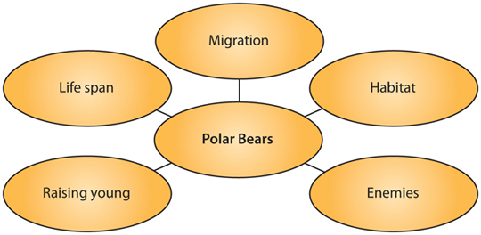
If instead, they apply a conceptual lens to their investigation—migration, for example—they now gather information about polar bears, monarch butterflies, arctic fox, gray whales, and Canada geese in order to analyze migratory behavior. Again, they pose questions, but their questions are more complex (see Figure 2).
Figure 2. Concept-based. Identify attributes of migration and compare across exemplars.
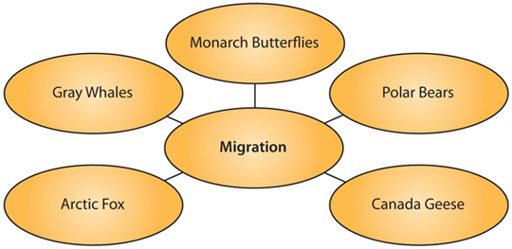
Table 1 lists examples of the types of questions explored for topics and those explored for concepts. One set is easily answered by quick fact searches in encyclopedias or on the Web. The other requires higher order thinking and contributes to a larger—and more enduring—understanding of migration.
Table 1. Conceptual lens yields deeper questions
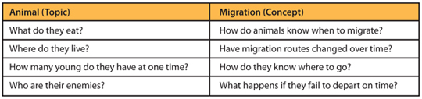
To take that notion further, consider the examples of shifts in Table 2. Evident in these shifts is a move from the particular and concrete to the broad and abstract. While this shift seems contrary to the continuing effort to "narrow a topic," it is the abstract thinking that causes students to need to think more deeply and inductively. Most importantly, what will be the learning outcomes of each?
Table 2. Shift from topic to concept
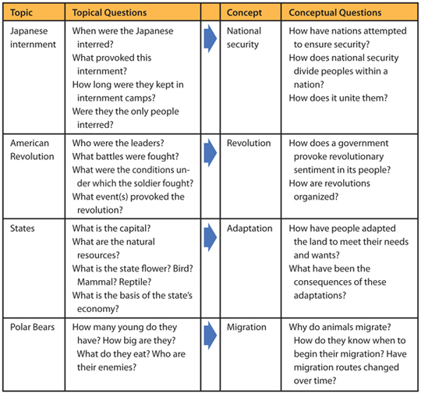
While it may be tempting to assume that this conceptual learning is too difficult for elementary school students, it is important to note that the concept-based Taba Social Studies curriculum was an elementary school curriculum with such conceptual units as Family, Community, Culture, Revolution, and Immigration. Conceptual understandings can be developed in young children; the examples and dimensions increase in complexity through the grades, but concepts are not beyond the grasp of young children.
Value beyond school. Authentic inquiry by definition has value beyond school—either in the content learned or the processes of the learning. When the shift from a fact-based to a concept-based inquiry occurs, there is greater likelihood that the investigation will have value beyond school because abstract concepts have transferability. For example, in the example of Latin American studies, when students study a particular Latin American country, when will the facts they acquire be of use for them beyond school? Most directly, this information may have personal meaning and relevance if they travel to the country—marginally likely for the majority of students. When they study economic development, when will the understandings have personal meaning and relevance for them? These understandings will have relevance if they examine how their findings apply to their own country, state, or community. The potential for relevance emerges because of the universality and timelessness of abstract concepts

